Testing Documentation for RentalNinja

1. get-presigned-url

- Method: POST
- Endpoint: /get-presigned-url
- Test Objective: Verify that the API returns a valid presigned URL for uploading a file to AWS S3.
- Test Data: No request body required.
- Expected Result: A presigned URL is successfully returned.
- Screenshot:
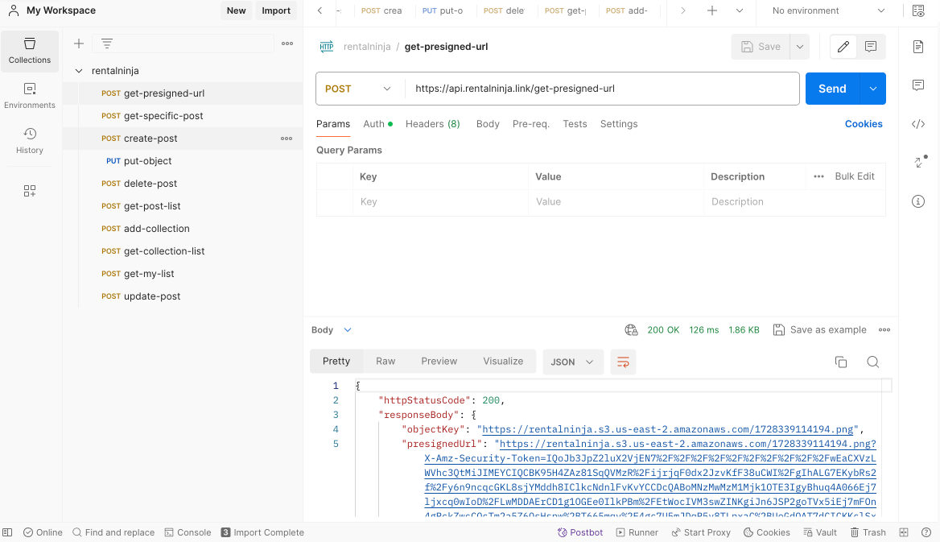
2. get-specific-post

- Method: POST
- Endpoint: /get-post-detail
- Test Objective: Verify that the API correctly retrieves the details of a specific post.
- Test Data:
{
"postId": "873c1deb-6dd3-4be2-8c9c-2850eb5caf87"
}
- Expected Result: The correct post details are returned, including title, content, and metadata.
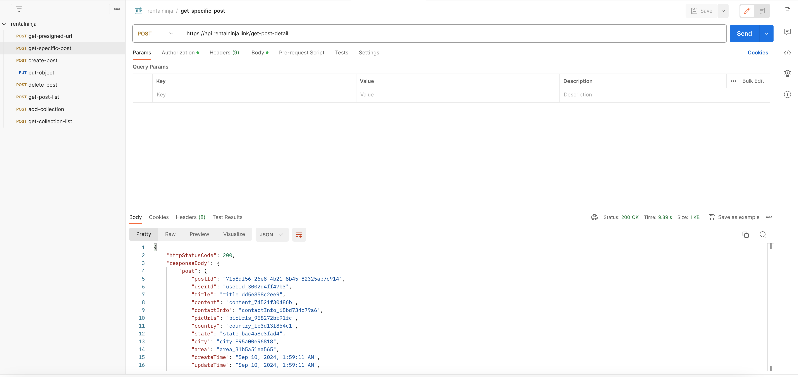
3. create-post

- Method: POST
- Endpoint: /upload-post
- Test Objective: Verify that the API successfully creates a new post with all required fields.
- Test Data:
{
"userId": "userId_3002d4ff47b3",
"title": "testttttt",
"content": "13213123123213",
"contactInfo": "contactInfo_68bd734c79a6",
"picUrls": "picUrls_958272bf91fc",
"countryCode": "country_fc3d13f854c1",
"stateCode": "state_bac4a8e3fad4",
"cityCode": "city_895a00e96818",
"price": 100,
"area": "area_31b5a51ea565"
}
- Expected Result: The post is successfully created and a success message is returned.
- Screenshot: 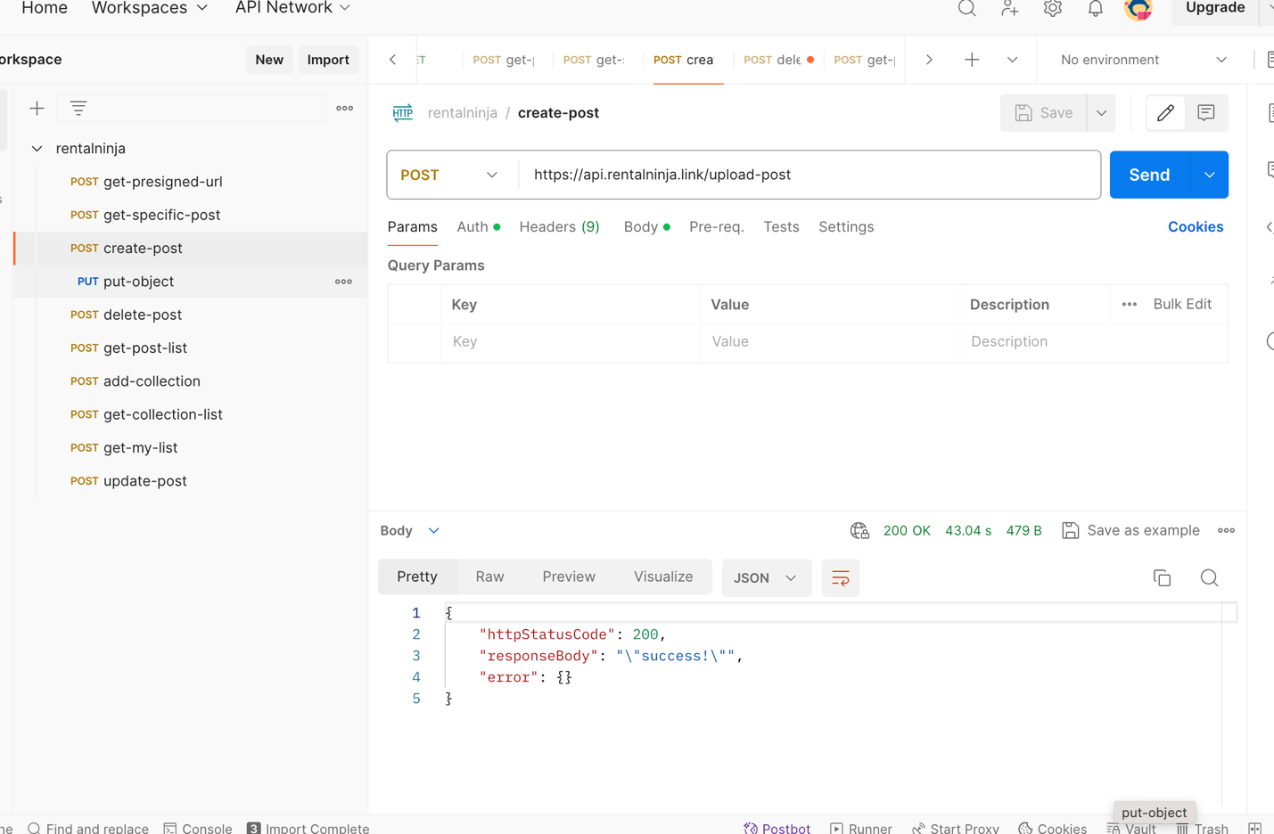

4. put-object

- Method: PUT
- Endpoint: AWS S3 Presigned URL
- Test Objective: Verify that the file is successfully uploaded to S3 using the provided presigned URL.
- Test Data: File upload (e.g., image or document).
- Expected Result: The file is successfully uploaded.
- Screenshot:
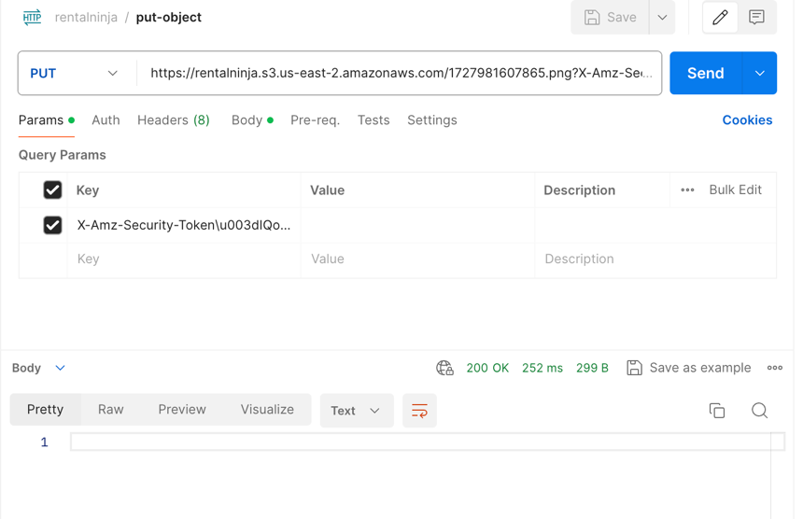
5. delete-post

- Method: POST
- Endpoint: /delete-post
- Test Objective: Verify that the API successfully deletes the specified post.
- Test Data:
{
"postId": "7158df56-26e8-4b21-8b45-82325ab7c914"
}
- Expected Result: The post is successfully deleted and a success message is returned.
- Screenshot:
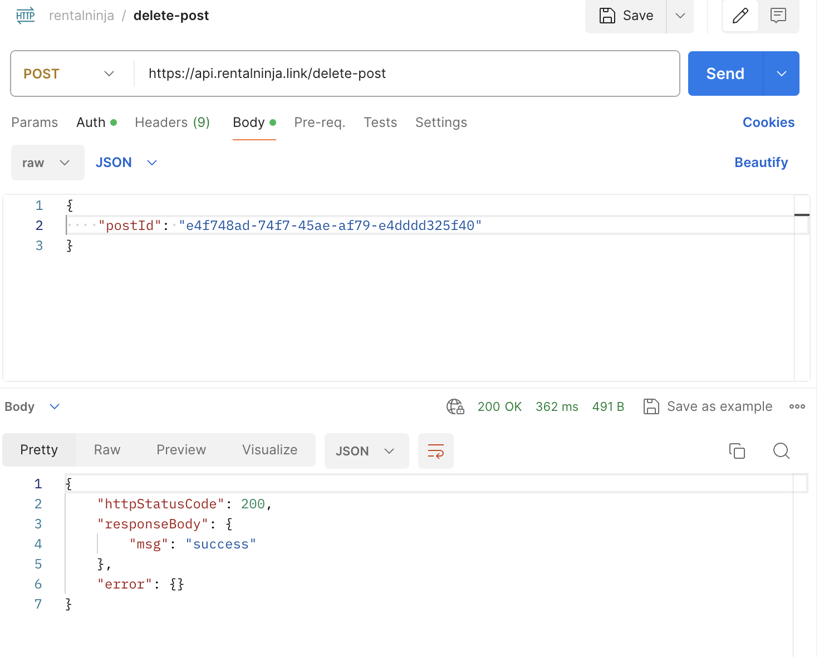
6. get-post-list

- Method: POST
- Endpoint: /get-post-list
- Test Objective: Verify that the API retrieves a list of posts based on the provided search parameters.
- Test Data:
{
"stateCode": "",
"cityCode": "",
"keyword": "",
"pageNum": 0,
"pageSize": 2
}
- Expected Result: A list of posts is successfully retrieved.
- Screenshot:
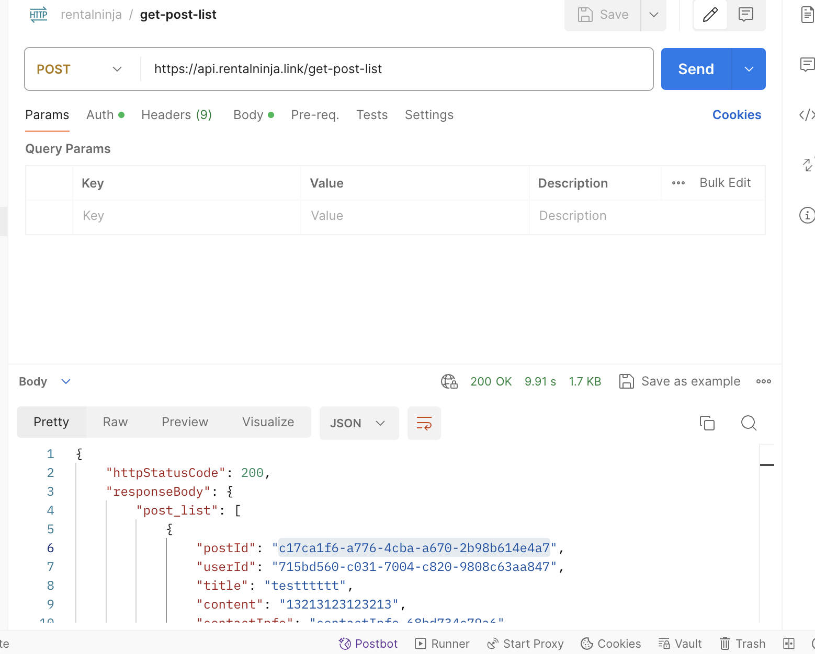
7. add-collection

- Method: POST
- Endpoint: /add-collection
- Test Objective: Verify that the API correctly adds or removes a post from the user's collection.
- Test Data:
{
"postId": "226de9e3-85c6-4ab6-8e6c-152c7e3f2eff",
"isAdd": 1
}
- isAdd: 1 to add to collection, 0 to remove.
- Expected Result: The post is successfully added or removed from the collection.
- Screenshot:
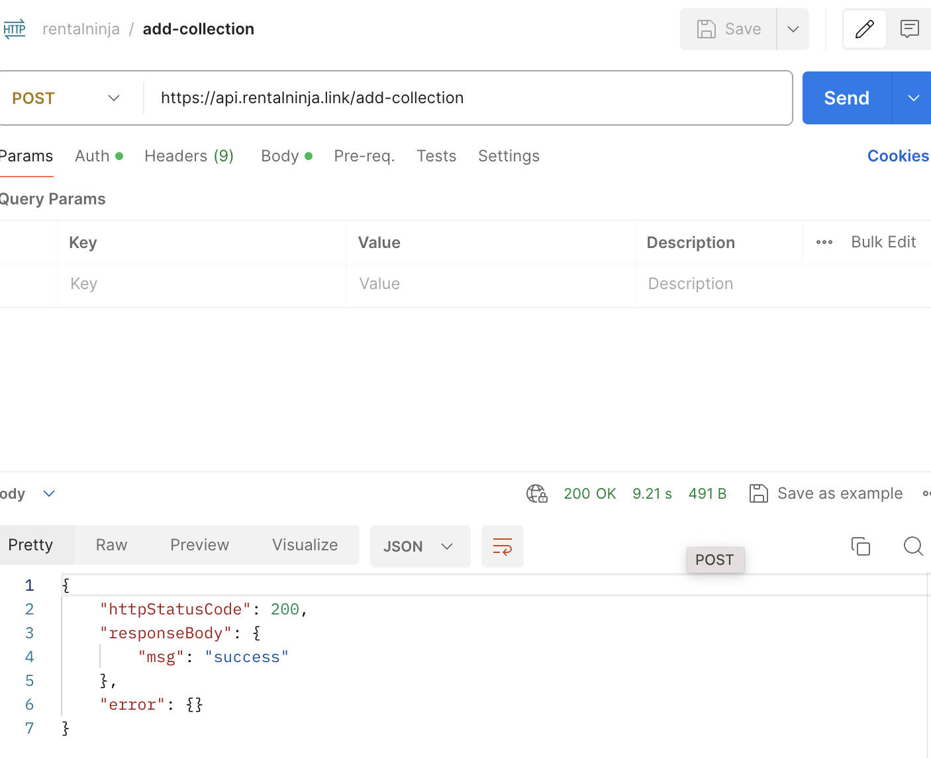
8. get-collection-list

- Method: POST
- Endpoint: /get-collection-list
- Test Objective: Verify that the API retrieves the list of collected posts for the user.
- Test Data: No request body required.
- Expected Result: The collected posts are successfully retrieved.
- Screenshot:
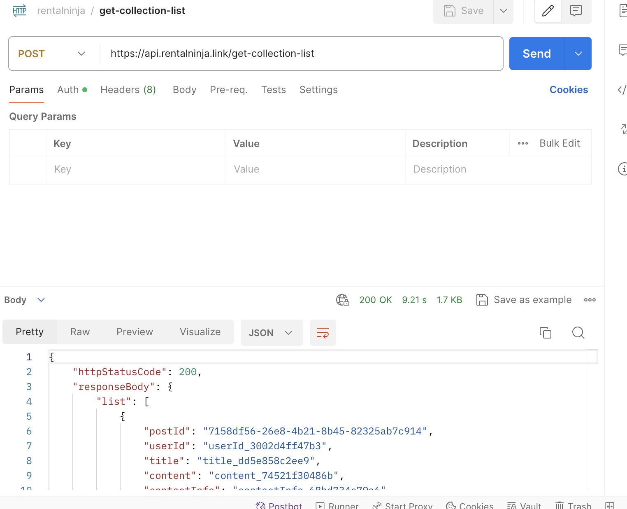
9. get-my-list

- Method: POST
- Endpoint: /get-my-list
- Test Objective: Verify that the API retrieves the list of posts created by the user.
- Test Data:
{
"pageNum": 0,
"pageSize": 10
}
- Expected Result: A list of user-created posts is successfully retrieved.
- Screenshot:
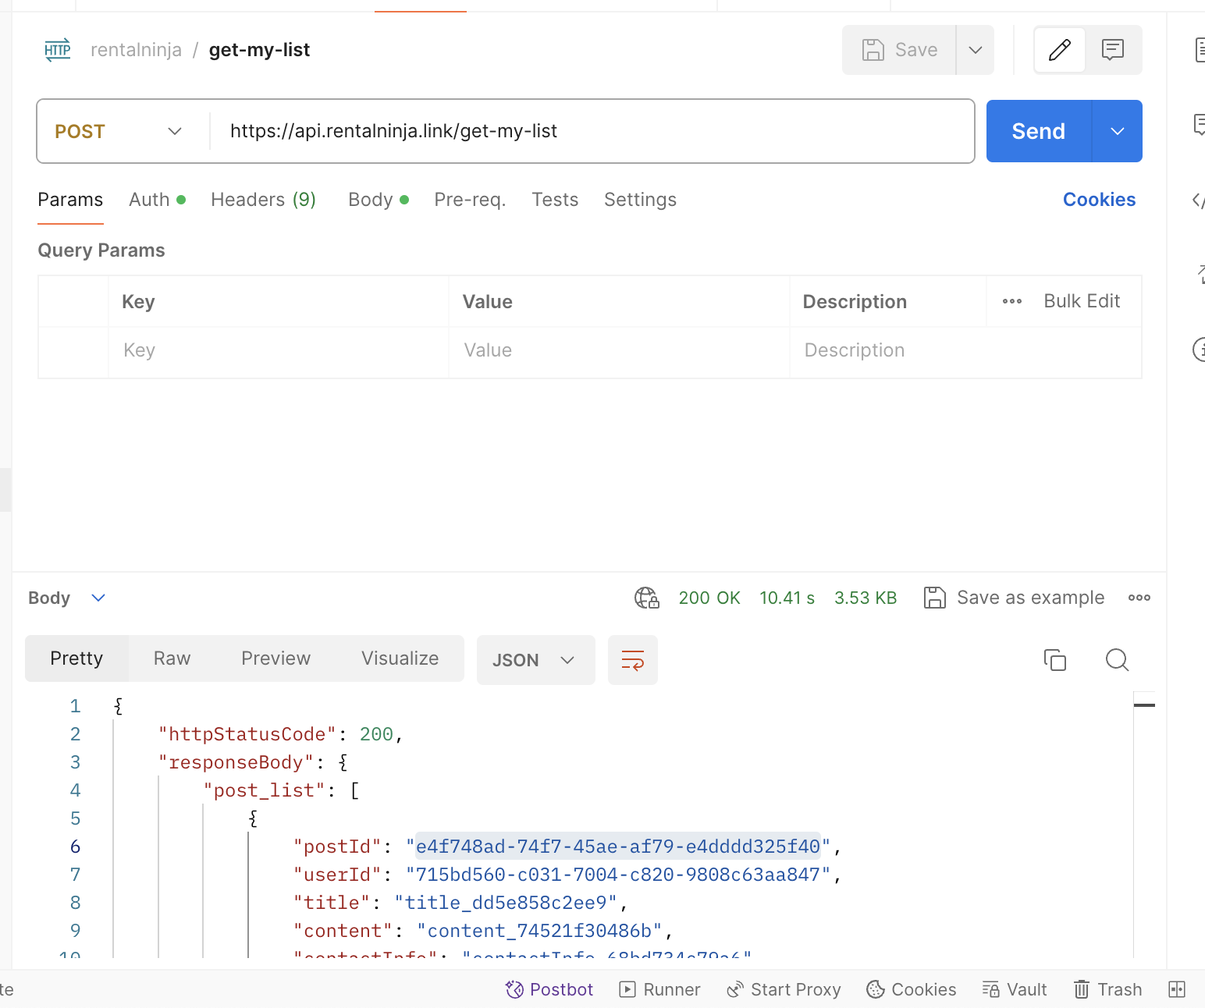
10. update-post

- Method: POST
- Endpoint: /update-my-post
- Test Objective: Verify that the API successfully updates an existing post with new information.
- Test Data:
{
"postId": "873c1deb-6dd3-4be2-8c9c-2850eb5caf87",
"title": "testttttt",
"content": "13213123123213",
"contactInfo": "contactInfo_68bd734c79a6",
"picUrls": "picUrls_958272bf91fc",
"countryCode": "country_fc3d13f854c1",
"stateCode": "state_bac4a8e3fad4",
"cityCode": "city_895a00e96818",
"price": 100,
"area": "area_31b5a51ea565"
}
- Expected Result: The post is successfully updated.
- Actual Result:
{
"message": "Internal server error"
}
- Screenshot: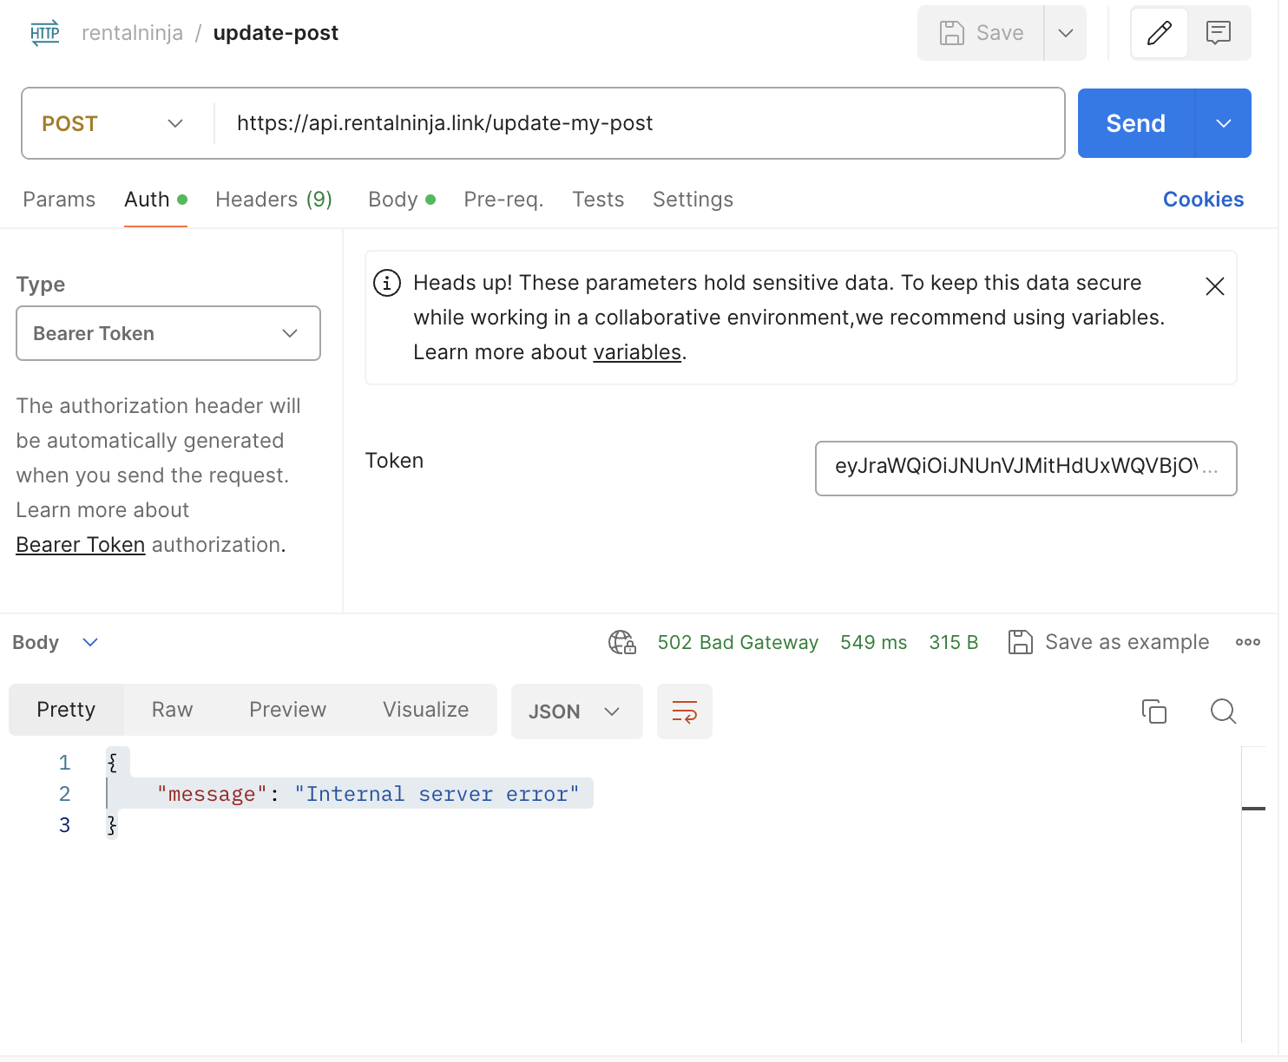

Exception Cases
1.Token Expired
Scenario: The user's token has expired, and the API request is made with an invalid token.
Expected Response:
{
"message": "The incoming token has expired"
}
Affected Endpoints: All endpoints that require authentication.
Screenshot:
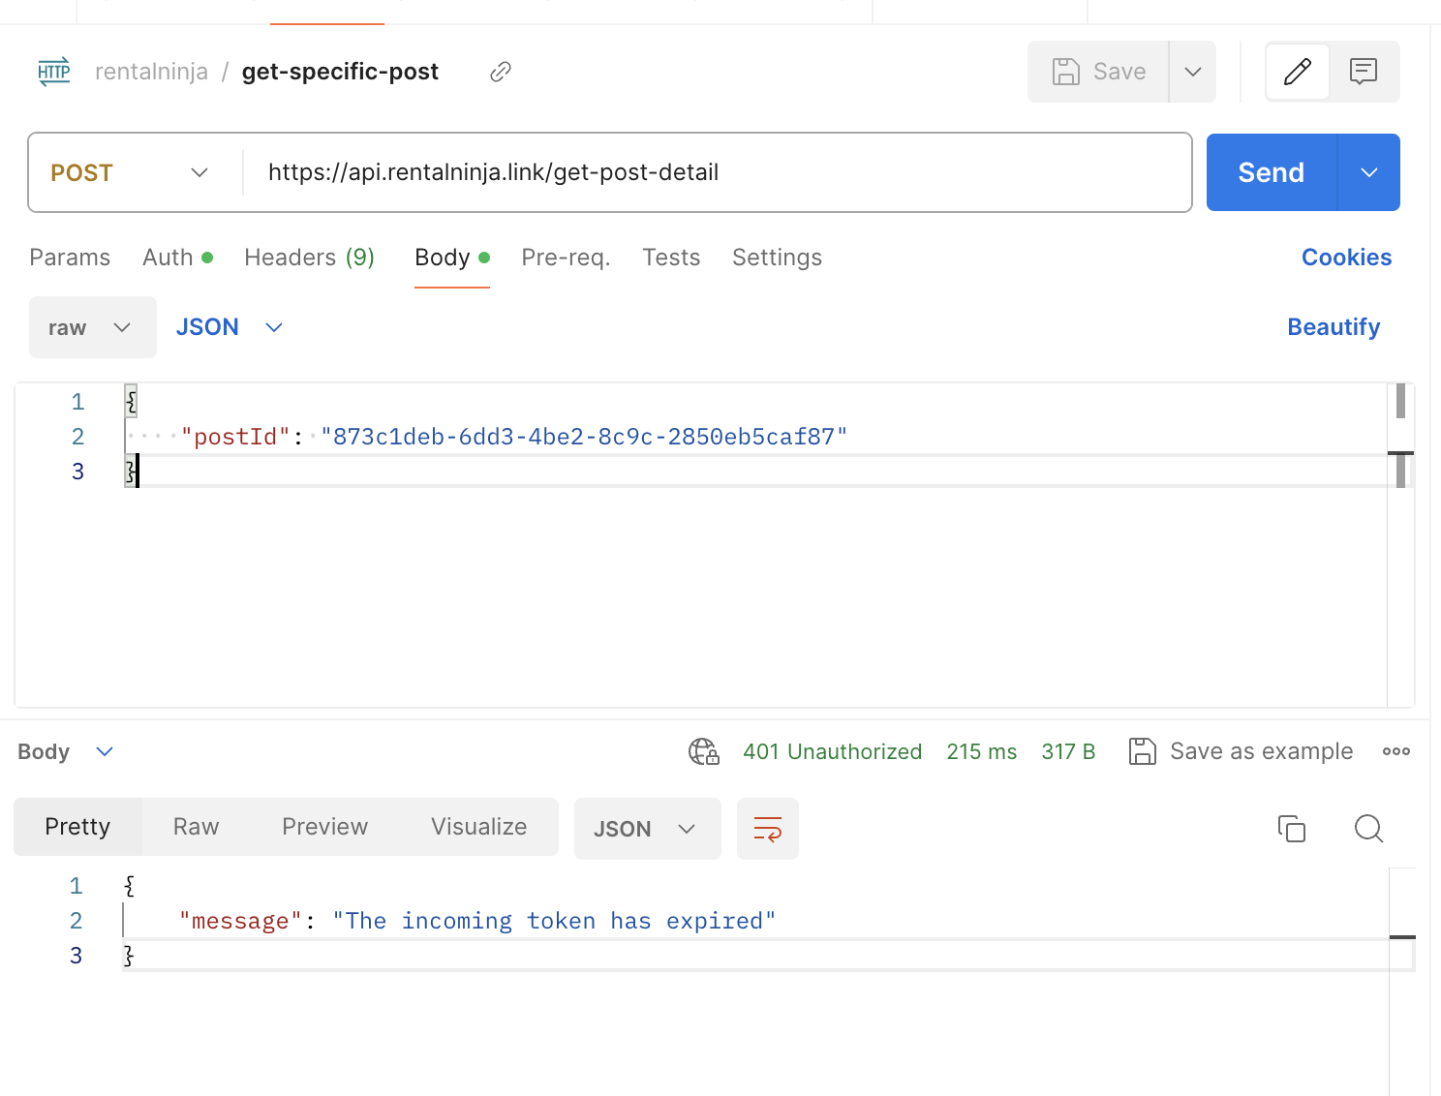
2.Server Error
Scenario: The server encounters an internal error while processing the request.
Expected Response: